Dear Sir,

I would like to take this opportunity to introduce Naomi Direct Radiology solution.

The company was established in 1993 in Nagano, Japan with a capital of almost a billion yen and has over 175 employees. They have a branch office in four cities in Japan (Tokyo, Nagoya, Osaka, Fukuoka) and offices in LA and New York in the United States. In addition of the DDR product they manufacture products for dental applications, industrial applications and endoscopy etc. The company has been selected as “Top 300 small and medium enterprises in 2009” in Japan.

Naomi is a Japanese product, with No. 1 market share in Japan due to its quality, versatility and economic price.

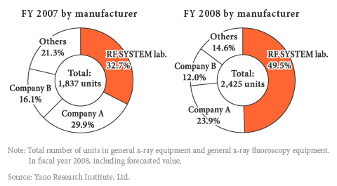

Naomi’s DR system has some unique advantages over CR systems and conventional x-ray systems:

- Naomi is one of the only DR systems that can be connected to low frequency x-ray generators (old x-ray machines). Most other more expensive flat panel systems can only be connected to x-ray machines with high frequency generators, usually requiring hospitals to upgrade their existing systems. This is makes Naomi a cost effective and versatile DR solution.
- Better image quality than CR systems as the technology is new and worldwide trends indicate that CR sales will drop and all new digital x-ray purchases will be of DR only. Trends also indicate that first movers to CR have already started to upgrade their systems to DR. 192 mono chrome CCD provide a 48.37 megapixel image which is of high quality. Some studies such as, Bronchotric in Chest X-ray, Head Sinus and Neck Thorasis Bone are hard to do in CR systems and are good in DR.

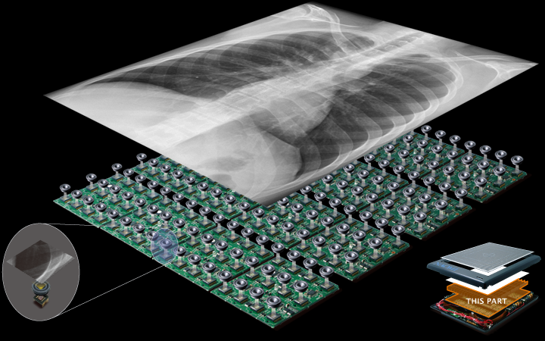

- Naomi DR comes along with image capture and manipulation software which allows modifying the image to suit our needs and also to zoom into the area of interest. None of this was possible with conventional systems, where only the base image could be used. You can add annotations, zoom, negative-positive changeover, rotate, reflect, adjust brightness, contrast etc.

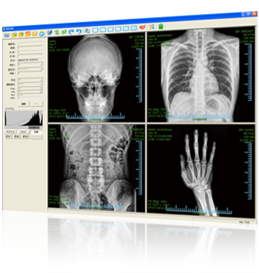
- Less dosage to patients than CR systems, which lead to safer operation of the system for patients, doctors and operators, reducing unnecessary exposure to harmful x-rays which may lead to health complications in the long run. The high sensitivity and high resolution of the specially developed TST-CCDs (270,000 pixel CCD sensor) leads to the low dosage which is gentle on the patient. You can clearly see the difference below, at 100 kvp and 3mAs exposure, there is low contrast in the film image vis-à-vis Naomi images at the same exposure level.

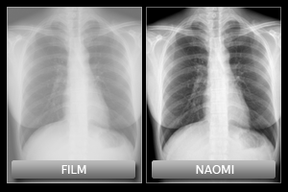

- Image acquisition time is less than 30 seconds (6 seconds after exposure), whereas, in CR you have to select the relevant plate, take the exposure then put the plate into the reader and wait till the image is acquired, this process takes a few minutes. In case of an analogue system we would have to wait till the film has developed, this takes almost 15 minutes. This is especially helpful when you have a high throughput of patients.

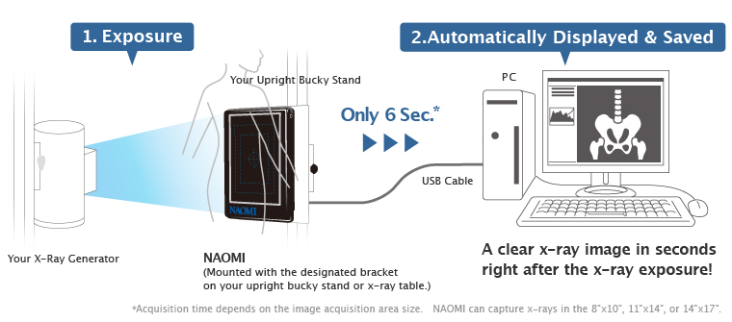
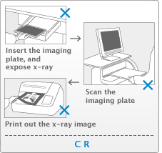 | 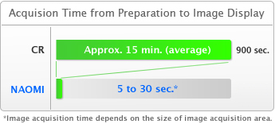

- Since the image is acquired in seconds, in case of any accident or serious cases, another exposure can be taken immediately if a mistake is made. Thereby, reducing the discomfort of the patient and aiding quicker diagnosis of the problem, giving the patients a better chance of recovery in certain cases.
- Cost saving are possible with Naomi:
  - Space required for the x-ray room is less since a dark room is not required; this will free-up space in existing hospitals.
  - Space is also saved vis-à-vis CR as there is no need to have a reader or store plates
  - Cost of chemical, film, film jacket, labour to develop film, maintenance etc. are saved. This in also eco-friendly way of doing x-rays.
  - In CR systems, the image plates are consumables and have a life, they need to be purchased, whereas in DR there are no such plates
  - Low maintenance costs

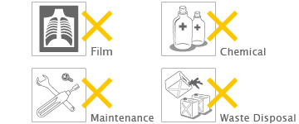

- Images can be shared with any computer system in the hospital or outside, in DICOM format for study, reference etc... This is a great advantage for operating x-ray systems in remote places, where with the use of a tele-radiology software the image can be sent anywhere in the world for diagnosis, reporting, analysis and/or second opinions.
- All images can be digitally stored for a later date helping the hospital keep a detailed record without taking up any space. In some places, hospitals by government law or internal policy are required to store images for a certain period of time. If volumes are large, this can turn into a bit of a mess with a lot of labour, effort and space going into categorising, referencing, storing and retrieving these images. With a DR system, the images are digital and can be stored as softcopies on a computer/server completely doing away with a need for the above.
- Survey results from Naomi users, on the Naomi system compared to the CR is as below:

